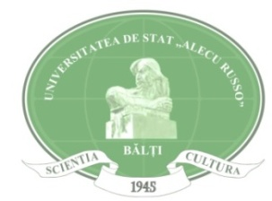
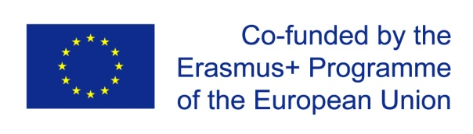

Erasmus + Programme
Key Action 1
Academic year 2018 -2019

Available Scholarships for Alecu Russo Balti State University

University Name | University of A Coruña, Spain (UDC)
University Web Page | www.udc.es
Field of Study | - Civil Engineering (courses offered in Spanish)  - Mechanical Engineering (courses offered in Spanish)  - Sciences (courses offered in English)
Type of mobility | BA, MA, PhD
Required documents | - Copy of ID and Passport  - CV  - Transcript of records from home university (original and authorized translation into English/ certificate issued in English)  - Proof of registration as a student, issued by home university, which confirms the level and year of study during the current academic year and the expected date of graduation (original and authorized translation into English/ certificate issued in English)  - Language certificate (for the language of instruction of the particular study programme in the host university)  - Motivation statement  - Learning Agreement (filled in with information on the student and the home university, in the section Before the mobility – Table A and signed by the student and the home university (in the section Commitment)  - Copy of Bachelor Diploma and Bachelor Diploma Supplement (for Master students)  - For PhD students it is strongly recommended to arrange with UDC Faculty members a learning agreement to guarantee the availability of their proposed study plans at UDC  UDC offers some courses in English. For more information: http://www.udc.gal/ori/internacionalizacion/programmesinenglish/content/facultades/index.html?language=en
Application Procedure | The file (printed and electronic PDF format) will be presented to your home University to Svetlana Melnic, International Relations Coordinator (Department of International Relations, Office 142, Administrative Building, email: melnic.svetlana@usarb.md).  The selected candidates will have to fill in the online application procedure afterwards via the UDC portal.  More information in the following link:  https://www.udc.es/ori/infestudantesextranxeiros/Erasmus-KA107/ErasmusKA107.html?language=en
Eligibility criteria | Home university will provide a pre-selection of candidates according to the following criteria:  - Students enrolled at Bachelor, Master’s and PhD Levels  - Students who have successfully completed at least 1 year of study (for BA) and at least 1 semester of studies (for MA and PhD)  - Students who are enrolled in one of the fields of study offered at University of A Coruña, Spain (UDC)  - Students with good academic record  - Students who are highly motivated  - Awareness and good knowledge of the Erasmus + programme  - Any other information indicated by the applicant (additional learning experience, specific academic interest, vulnerable socio-economic situation, etc.)
Language Requirements | Students are expected to demonstrate English/Spanish proficiency corresponding to at least B1 level of the Common European Language Framework of Reference.
Deadline | May 26th, 2018

