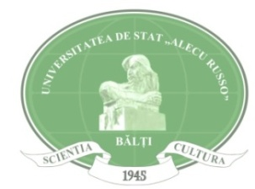
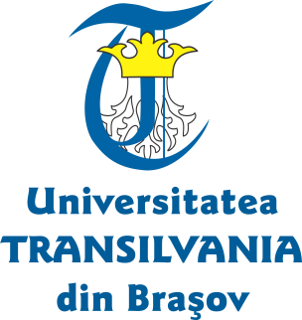
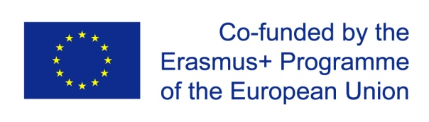

Erasmus + Programme
Key Action 1
Academic year 2018 -2019

Available Scholarships for Alecu Russo Balti State University

University Name | Transilvania University of Brasov, ROMANIA
University Web Page | https://www.unitbv.ro/
Field of Study | - Sociology and cultural studies  - Journalism and reporting
Type of mobility | Staff for TEACHING – 5 days
Required documents | - Copy of ID and Passport  - CV and List of Publications  - Proof of employment, issued by home university (original and authorized translation into English)  - Motivation Statement (stating the motivation for applying for the Erasmus+ scholarship and describing the activities planned for the duration of the mobility in the host university)  - Work Plan will outline the teaching activities, outcomes and objectives agreed with the prospective Host Supervisor  - Support Letter (Pre-Acceptance Letter) issued by the prospective Supervisor at the Host University. In the Support Letter, the Supervisor will confirm his/her willingness to host the candidate and mentor him/her in the activities outlined in the Work Plan. The support letter will also provide evidence of candidate language proficiency and it may possibly include information about the tentative mobility period.  - Language certificate (for the language of instruction of the particular study programme in the host university)  Additional info can be accessed on:  http://old.unitbv.ro/orien/Staffmobility/Teaching-STA.aspx
Application Procedure | The file (printed and electronic PDF format) will be presented to your home University to Svetlana Melnic, International Relations Coordinator (Department of International Relations, Office 142, Administrative Building, email: melnic.svetlana@usarb.md).
Eligibility criteria | Home university will provide a pre-selection of candidates according to the following criteria:  - CV and List of Publications  - Support Letter  - Work Plan  - Program Motivation  - Awareness and good knowledge of the Erasmus + programme  - Any other information indicated by the applicant (additional learning experience, specific academic interest, vulnerable socio-economic situation, etc.)
Language Requirements | Academics are expected to demonstrate Romanian/English proficiency corresponding to at least B2 level of the Common European Language Framework of Reference.
Deadline | May 26th, 2018

