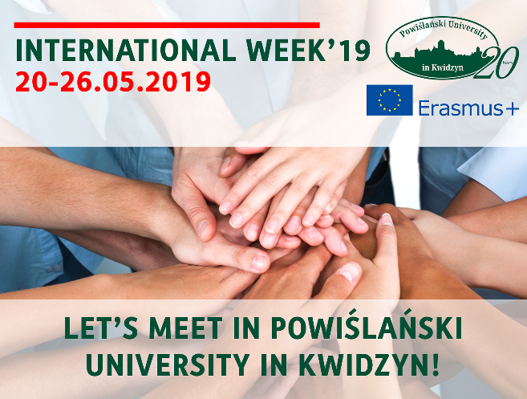
Powiślański University in Kwidzyn
International Week 2019

Dear Partner,
We are organising our 1st International Week, which will be held on 20-26th of May 2019. We would like to invite all our partners to participate in all activities.
On 24th of May Powiślański University in Kwidzyn is organizing the 1st International Student Conference.
On 25 May, the 2nd Higher Education Fair "Future is Yours" will be held in the Kwidzyn Industrial and Technological Park, it will be the International Education Fair of Universities. In addition to the demonstrations and presentations of the partner universities of the Powiślański College in Kwidzyn,.
The plan also includes a discussion panel - learning the future - the future in science.
In turn, on May 26, 2018, the 6th International Conference on "Faces of Prosperity" will be held.
For more information please see the attached files.
We hope you will join us for this important week in Poland.

Contact e-mail: internationaloffice@psw.kwidzyn.edu.pl

University website: https://psw.kwidzyn.edu.pl/
