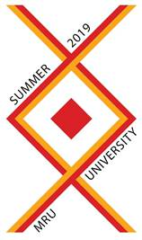

Summer University 2019: * Communication * Culture * Heritage * Security
Mykolas Romeris University (MRU) – Vilnius, Lithuania
From 22nd July 2019 to 8th August 2019

MRU Summer University is dedicated to 4 fields: communication, culture, heritage and security so the main program will include various lectures during the morning sessions, and (practical part) visits to social institutions or projects in the afternoon sessions from Monday to Thursday also excursions to various Lithuanian attraction points on Weekends!
It is a perfect opportunity to widespread world view, make friends and eventually get to know Lithuania! Also please keep in mind that MRU Summer University is designed for all Bachelor and Master Students, so a lot of connections and friendships are ahead.
With the detailed program you can introduce yourself here: http://summer.mruni.eu/?page_id=24
Regarding the applications please note that early birds can only be made until 30th May 2019 –NECESSARY FOR VISA REQUIRING COUNTRIES
The deadline for non-requiring participants is settled to the 10th of June 2019
Application form: https://bit.ly/2FYtR7d
Extra special price is offered for students from MOLDOVA!
Additional information: http://summer.mruni.eu/
Email: summer@mruni.eu
Facebook: https://www.facebook.com/events/299567677401391/

